HTML Forms Chapter 3- Students Handout
About Workshop
HTML forms are a fundamental part of web development. They allow users to input data, which can then be sent to a web server for processing. Forms are used for various purposes, such as user registration, login, search, and data collection. In this handout, you will learn how to create HTML forms and understand the key elements involved.
HTML5 is the fifth iteration of the Hypertext Markup Language, revolutionizing web development. With enhanced semantics and multimedia support, it offers a richer user experience. Features like Canvas enable dynamic graphics and animations, while offline capabilities cater to mobile and desktop apps. HTML5's responsive design and accessibility focus ensure a seamless, inclusive web. This standard has ushered in a new era of interactive and feature-rich web content.

Workshop 1:

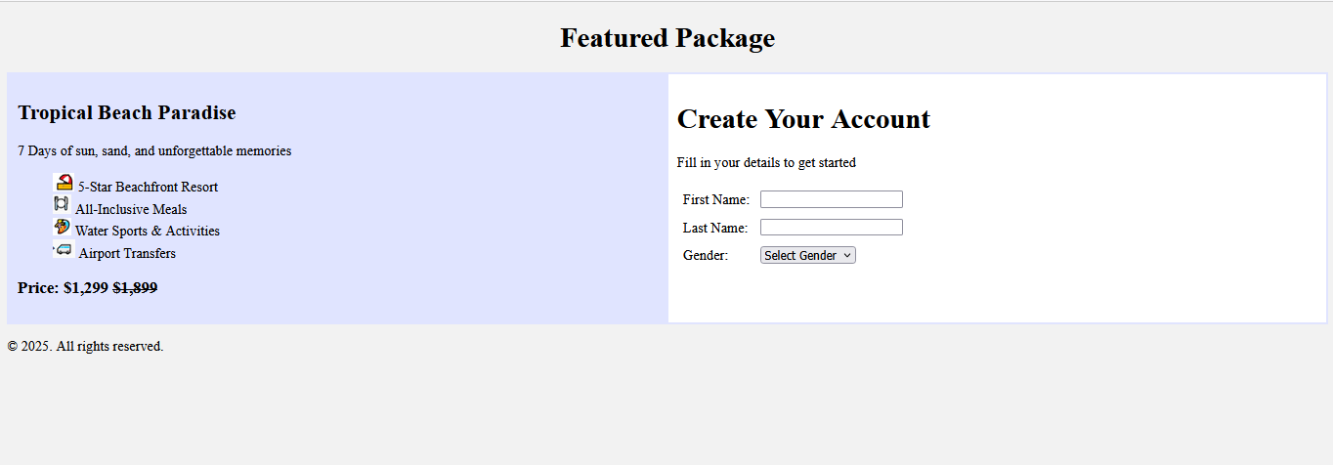

Expected Output:

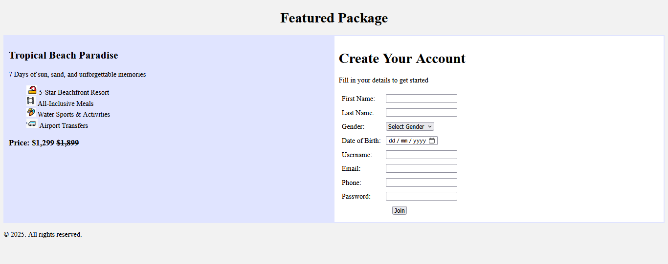
In this workshop, forms have been created and a few fields have been added. You are requested to add the remaining fields.
Workshop 2
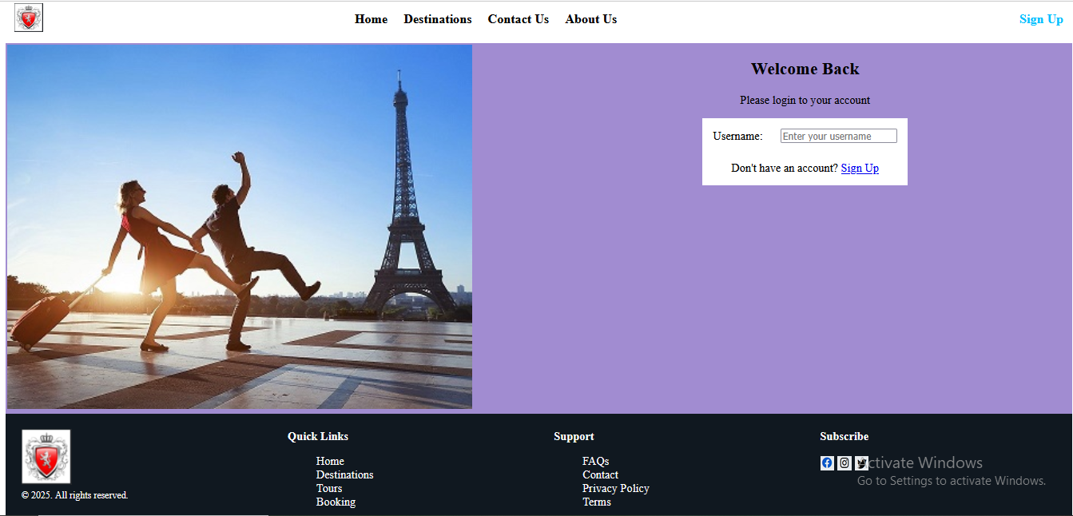

Expected Output:
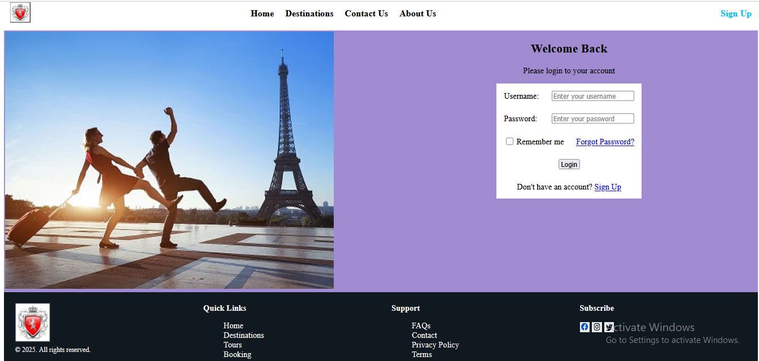
In this workshop, forms have been created and a few fields have been added. You are requested to add the remaining fields.

Workshop-3
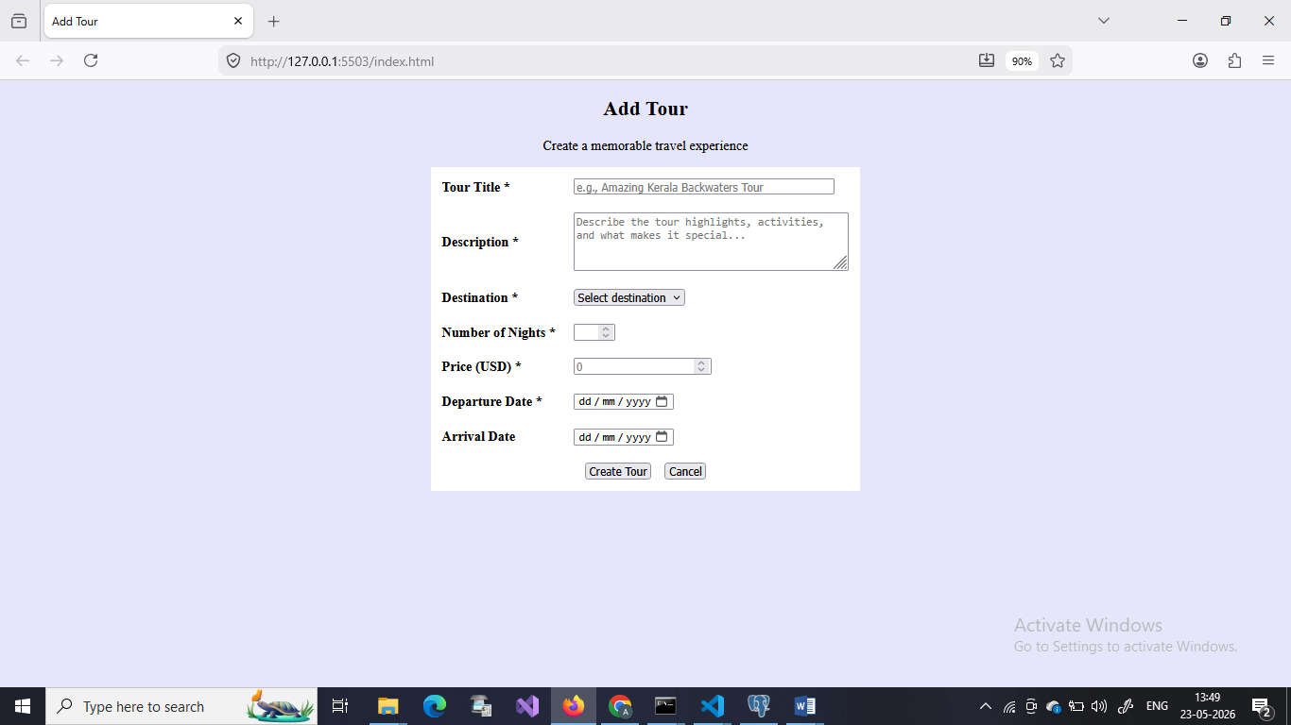

Expected Output:

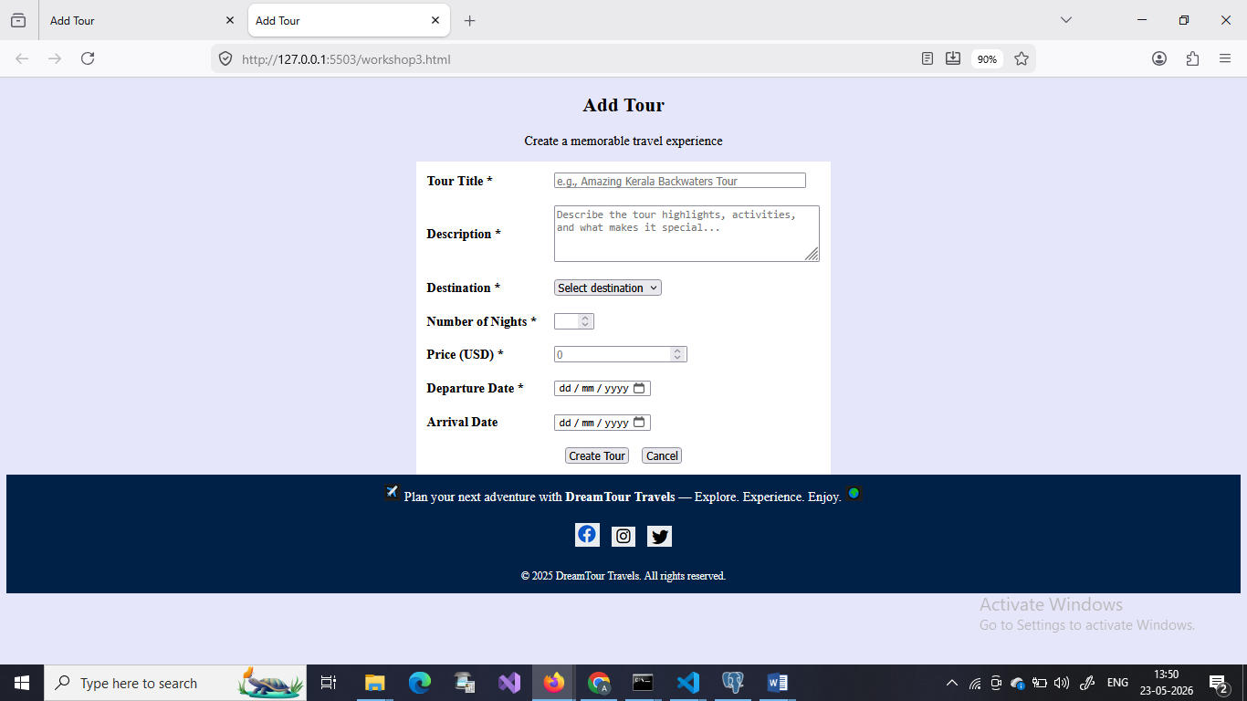

Workshop-4

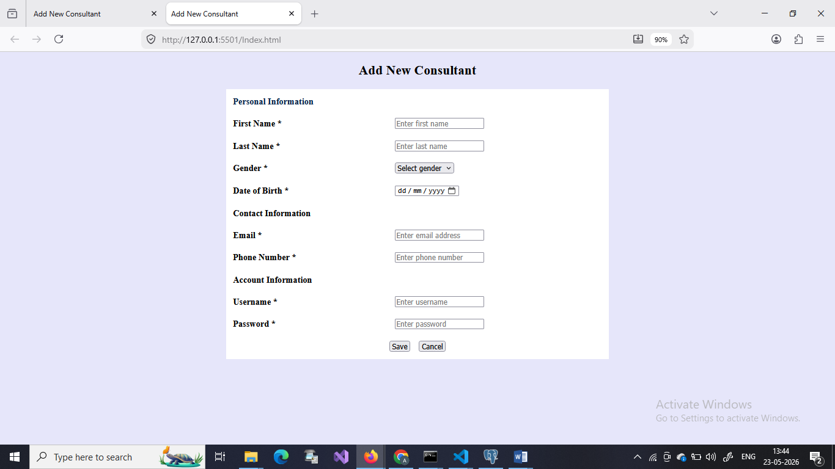

Expected Output:
